**Online portal for tracking Seeds Record for Cultivation**

**Software Requirements Specification**

Version 1.0



**Group Id: S25PROJECTD16AA**

**Supervisor Name :** MIR SALAM KHAN

**Revision History**

|  |  |  |  |
| --- | --- | --- | --- |
| Date (dd/mm/yyyy) | Version | Description | Author |
| 21/5/2025 | 1.0 | 1.0 This SRS outlines the functional and non-functional requirements for the "Online Portal for Tracking Seeds Record for Cultivation. A web-based system aimed at digitizing seed record management in Pakistan’s agriculture sector. It includes three main roles: Admin, Seed Agents (farmers, researchers, firms), and End-Users, ensuring smooth access, seed traceability, online transactions, and efficient stakeholder communication. The system covers seed browsing, profile viewing, order placement, payments, and data dashboards. Functional requirements include registration, login, seed uploads, approvals, and transactions. Non-functional requirements focus on performance, security, usability, and scalability. Use case diagrams show interactions like searching seeds and uploading records, while usage scenarios explain workflows such as agent registration and seed ordering. The system is built using the VU Process Model, combining Waterfall and Spiral methods. A structured work plan created with MS Project guides each phase from planning to deployment. | BC210424367 |
|  |  |  |  |
|  |  |  |  |
|  |  |  |  |

**Table of Contents**

1. Scope (of the project) Page No**: 04**
2. Functional Requirements Non Functional requirements Page No: **05,06**
3. Use Case Diagram Page No: **07**
4. Usage Scenarios  Page No: **08**
5. Adopted Methodology  Page No: **15**
6. Work Plan (Use MS Project to create Schedule/Work Plan)__________Page No: **20**

SRS Document

# *1. Scope Of Project:-*

# The scope of the "Online Portal for Tracking Seeds Record for Cultivation" is to develop a centralized, web-based platform that modernizes seed record management in Pakistan’s agricultural sector. The system is designed to streamline the processes of seed tracking, agent registration, order placement, and transaction management by connecting three key users: Admin, Seed Agent (farmers, researchers, firms), and End-User. It replaces traditional manual and spreadsheet-based systems with a secure and efficient digital solution.Admins will operate through a secure backend panel where they can approve seed agent registrations, assign login credentials, and manage seed data submissions. They also have access to analytical dashboards to support data-driven decisions that enhance transparency and oversight across the system.Seed Agents can register, log in after admin approval, and upload detailed information about seed varieties, including their characteristics and availability. They can manage contact information, enable payment options, and maintain their profiles, offering reliable seed traceability and availability information to users.End-Users can explore seed categories, view agent profiles, place orders, and manage transactions through a user-friendly interface accessible via web or mobile. The system allows real-time data interaction, improving convenience and enhancing the decision-making process regarding seed selection and cultivation practices.n summary, this platform delivers an automated, transparent, and scalable solution that supports sustainable agriculture. It improves operational efficiency, promotes informed cultivation choices, and strengthens communication between stakeholders within the agricultural ecosystem. This system ultimately empowers the agricultural community with accurate, accessible, and up-to-date seed information. It contributes to improved productivity, sustainability, and digital transformation in Pakistan’s agriculture sector. By integrating technology into seed management, the platform reduces dependency on outdated record-keeping methods. It fosters collaboration among farmers, researchers, and firms for better agricultural outcomes.

# .*2.1 Functional Requirements:-*

**End-User:**

* The end-user visits the seeds web portal through a domain name.
* The user searches different categories of seeds.
* The user searches the required seeds with full details.
* The user can search the seed agent (farmer, researcher, or firm) profile.
* The user can place an order to buy/sell seeds.
* The user can manage transactions and payment processing.

**Seed Agent:**

* The seed agent registers on the portal by filling out the required form.
* After admin approval, the agent can log in and upload seed details after authentication.
* The agent provides relevant contact information.
* The agent provides online payment methods.

**Admin:**

* The admin logs into the system.
* The admin grants approval to registered farmers, researchers, and agricultural centers.
* The admin provides usernames and passwords to farmers, researchers, and agriculture centers or firms.
* The admin provides an analytical dashboard to support better decision-making.

# *2.2 Non-Functional Requirements:-*

* **Security** – Secure authentication, data encryption, and compliance with industry security standards.
* **Performance** – The system should handle multiple concurrent users without performance degradation.
* **Scalability** – Ability to scale up to accommodate more users and fitness centres.
* **Usability** – Intuitive and user-friendly interface for all users.
* **Availability** – The system should have high uptime and reliability.
* **Compatibility** – The platform should be accessible across different web browsers and devices. Maintainability – Easy to update and modify features without major downtime.
* **Backup & Recovery** – Regular data backups and recovery mechanisms to prevent data loss.

# *3. Use Case Diagram:-*

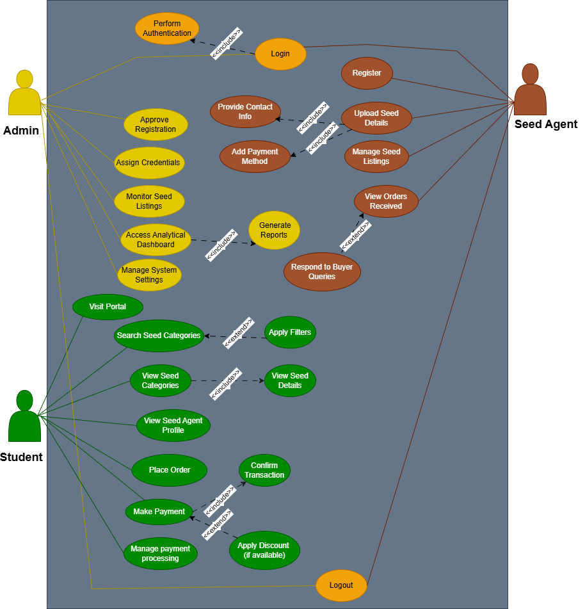

# 

# *4. Usage Scenario Tables:-*

|  |  |
| --- | --- |
| Use Case | Register on Portal |
| Actor | Seed Agent |
| Description | Agent registers by submitting required info. |
| Alternative Path | Retry with different info |
| Pre Conditions | User must not be already registered |
| Action | Fill form and submit |
| Post Conditions | Await admin approval |
| Exception | Validation error |
| Author | BC210424367 |
| Modification History | **Initial version V1.1** |

|  |  |
| --- | --- |
| Use Case | Login to Account |
| Actor | Seed Agent, Admin |
| Description | Agent/admin logs in using credentials. |
| Alternative Path | Forgot password |
| Pre Conditions | Agent must be approved |
| Action | Enter credentials and submit |
| Post Conditions | Dashboard access granted |
| Exception | Invalid login |
| Author | BC210424367 |
| Modification History | **Initial version V1.1** |

|  |  |
| --- | --- |
| Use Case | Upload Seed Details |
| Actor | Seed Agent |
| Description | Agent uploads detailed info of seeds. |
| Alternative Path | Bulk upload option |
| Pre Conditions | Agent must be logged in |
| Action | Fill form,  attach documents  submit it |
| Post Conditions | Seed details visible |
| Exception | Incomplete data error |
| Author | BC210424367 |
| Modification History | **Initial version V1.1** |

|  |  |
| --- | --- |
| Use Case | Provide Contact Information |
| Description | Seed agent enters contact details while uploading seed info. |
| Alternative Path | Seed agent chooses to skip optional fields. |
| Pre Conditions | Seed agent is authenticated and uploading a listing. |
| Action | 1. Fill contact details in form 2. Click save 3. Info is validated and stored |
| Post Conditions | Contact info is linked to seed entry and profile. |
| Exception | 1. Missing required info 2. Invalid data format |
| Author | BC210424367 |
| Modification History | Part of upload seed detail include path |

|  |  |
| --- | --- |
| Use Case | Add Payment Details |
| Description | Allows seed agent to add one or more payment methods to receive payments. |
| Alternative Path | Payment method not supported or skipped. |
| Pre Conditions | Seed agent is logged in and accessing profile settings. |
| Action | 1. Select payment method 2. Enter account details 3. Save method |
| Post Conditions | Payment method saved and available for transactions. |
| Exception | 1. Invalid account info 2. Method unsupported |
| Author | BC210424367 |
| Modification History | Included in upload process for seed listings |

|  |  |
| --- | --- |
| Use Case | Manage Seed Listings |
| Actor | Seed Agent |
| Description | Agent edits or removes seed listings. |
| Alternative Path | Batch update |
| Pre Conditions | Agent must be logged in |
| Action | Select seed and choose action |
| Post Conditions | Changes saved |
| Exception | Unauthorized changes |
| Author | BC210424367 |
| Modification History | **Initial version V1.1** |

|  |  |
| --- | --- |
| Use Case | View Orders Received |
| Actor | Seed Agent |
| Description | Agent views orders from end-users. |
| Alternative Path | Sort by date or status |
| Pre Conditions | At least one order exists |
| Action | Click Orders tab  View list of orders |
| Post Conditions | Order list displayed |
| Exception | No orders found |
| Author | BC210424367 |
| Modification History | **Initial version V1.1** |

|  |  |
| --- | --- |
| Use Case | Respond To Buyers Quries |
| Description | Seed agent responds to questions raised by potential buyers. |
| Alternative Path | Buyer closes query or agent ignores query. |
| Pre Conditions | Buyer has submitted query on a seed listing. |
| Action | 1. Open buyer query 2. Type response 3. Submit response |
| Post Conditions | Response is sent to the buyer and marked as replied. |
| Exception | 1. Network error 2. Session timeout during response |
| Author | BC210424367 |
| Modification History | **Initial version V1.1** |

|  |  |
| --- | --- |
| Use Case | Visit Portal |
| Actor | End-User |
| Description | User visits the seed portal via domain URL. |
| Alternative Path | None |
| Pre Conditions | Internet connection |
| Action | Open browser, enter URL, press enter |
| Post Conditions | Homepage loads successfully |
| Exception | Page not found, network error |
| Author | BC210424367 |
| Modification History | **Initial version V1.1** |

|  |  |
| --- | --- |
| Use Case | Search Seed Categories |
| Actor | End-User |
| Description | User searches various categories of seeds. |
| Alternative Path | Advanced filter usage |
| Pre Conditions | User must be on homepage |
| Action | Enter keywords and click search |
| Post Conditions | Matching seed categories displayed |
| Exception | No results found |
| Author | BC210424367 |
| Modification History | **Initial version V1.1** |

|  |  |
| --- | --- |
| Use Case | View Seed Details |
| Actor | End-User |
| Description | User views detailed information about a seed. |
| Alternative Path | Click multiple items |
| Pre Conditions | Seed category must be visible |
| Action | Click on a seed item |
| Post Conditions | Detailed seed page loads |
| Exception | Seed not found |
| Author | BC210424367 |
| Modification History | **Initial version V1.1** |

|  |  |
| --- | --- |
| Use Case | View Seed Agent Profile |
| Actor | End-User |
| Description | User views the seed agent profile. |
| Alternative Path | Visit via seed page or direct search |
| Pre Conditions | Agent must be registered |
| Action | Click on agent name |
| Post Conditions | Profile details displayed |
| Exception | Profile not found |
| Author | BC210424367 |
| Modification History | **Initial version V1.1** |

|  |  |
| --- | --- |
| Use Case | Place Order |
| Actor | End-User |
| Description | User places an order for a seed. |
| Alternative Path | Order multiple seeds |
| Pre Conditions | User must be logged in |
| Action | Click Buy, add to cart, checkout |
| Post Conditions | Order confirmation message |
| Exception | Payment failed |
| Author | BC210424367 |
| Modification History | **Initial version V1.1** |

|  |  |
| --- | --- |
| Use Case | Make Payment |
| Actor | End-User |
| Description | User makes payment for seed order. |
| Alternative Path | Use different payment methods |
| Pre Conditions | Order placed successfully |
| Action | Select method, enter details, confirm |
| Post Conditions | Transaction success message |
| Exception | Transaction declined |
| Author | BC210424367 |
| Modification History | **Initial version V1.1** |

|  |  |
| --- | --- |
| Use Case | Confirm Transaction |
| Actor | End-User |
| Description | Verifies and confirms payment details for an order. |
| Alternative Path | Transaction fails; user retries or selects a different method. |
| Pre Conditions | User has selected payment method and filled payment info. |
| Action | 1. Review payment summary 2. Click Confirm 3. Transaction is processed |
| Post Conditions | Order is marked as paid and user gets a receipt. |
| Exception | 1. Transaction declined 2. Payment gateway timeout |
| Author | BC210424367 |
| Modification History | **Initial version V1.1** |

|  |  |
| --- | --- |
| Use Case | Apply Discounts(If available) |
| Actor | System (Extended for End-User) |
| Description | Applies available discounts to a transaction automatically. |
| Alternative Path | No discount available for the selected seed or user. |
| Pre Conditions | User is eligible and discount code or condition is met. |
| Action | 1. System checks eligibility 2. Discount is applied 3. New total displayed |
| Post Conditions | Discounted amount is reflected in the final payment. |
| Exception | 1. Invalid discount condition 2. System failure in applying discount |
| Author | BC210424367 |
| Modification History | **Initial version V1.1** |

|  |  |
| --- | --- |
| Use Case | Approve Registrations |
| Actor | Admin |
| Description | Admin approves new agent signups. |
| Alternative Path | Reject or ask for revision |
| Pre Conditions | Agent must be registered |
| Action | Click approve/reject |
| Post Conditions | Status updated |
| Exception | Action not saved |
| Author | BC210424367 |
| Modification History | **Initial version V1.1** |

|  |  |
| --- | --- |
| Use Case | Assign Credentials |
| Actor | Admin |
| Description | Admin sends username and password. |
| Alternative Path | Manual or automated |
| Pre Conditions | Agent must be approved |
| Action | Generate and send credentials |
| Post Conditions | Credentials delivered |
| Exception | Sending failed |
| Author | BC210424367 |
| Modification History | **Initial version V1.1** |

|  |  |
| --- | --- |
| Use Case | Monitor Seed Listings |
| Actor | Admin |
| Description | Admin reviews seed data uploaded. |
| Alternative Path | Sort by agent |
| Pre Conditions | Data must be available |
| Action | Open listing section |
| Post Conditions | Data viewable |
| Exception | Page crash |
| Author | BC210424367 |
| Modification History | **Initial version V1.1** |

|  |  |
| --- | --- |
| Use Case | Access Analytical Dashboard |
| Actor | Admin |
| Description | Admin accesses data analytics view. |
| Alternative Path | Drill-down into metrics |
| Pre Conditions | Data must exist |
| Action | Navigate to dashboard |
| Post Conditions | Graphs and stats shown |
| Exception | No data to display |
| Author | BC210424367 |
| Modification History | **Initial version V1.1** |

|  |  |
| --- | --- |
| Use Case | Generate Reports |
| Actor | Admin |
| Description | Admin generates analytical reports from the dashboard. |
| Alternative Path | Report generation delayed due to server load. |
| Pre Conditions | Admin is logged in and selects reporting module. |
| Action | 1. Select data range and category 2. Click Generate 3. View/download report |
| Post Conditions | Report is displayed or downloaded successfully. |
| Exception | 1. Invalid filter 2. Report fails due to database error |
| Author | BC210424367 |
| Modification History | **Initial version V1.1** |

|  |  |
| --- | --- |
| Use Case | Manage System Settings |
| Actor | Admin |
| Description | Admin configures system-level settings. |
| Alternative Path | Reset to default |
| Pre Conditions | Admin must be logged in |
| Action | Open settings, apply changes |
| Post Conditions | Settings saved |
| Exception | Invalid config |
| Author | BC210424367 |
| Modification History | **Initial version V1.1** |

|  |  |
| --- | --- |
| Use Case | Logout |
| Actor | All Users (Admin, Seed Agent) |
| Description | Allows users to securely log out from the system. |
| Alternative Path | User closes browser window directly. |
| Pre Conditions | User is already logged into the system. |
| Action | 1. Click on the logout button 2. Session ends 3. User is redirected to the homepage/login page |
| Post Conditions | User is logged out and session is terminated. |
| Exception | 1. Logout failure due to session timeout or server error. |
| Author | BC210424367 |
| Modification History | **Initial version V1.1** |

# . Adopted Methodology:-

**1.Waterfall Model:**

The Waterfall model is a linear, sequential software development process where each phase is completed before moving on to the next one, with no overlap or iteration. It follows a rigid structure, requiring fixed and well-defined requirements, and is suitable for projects with complexity and risk.

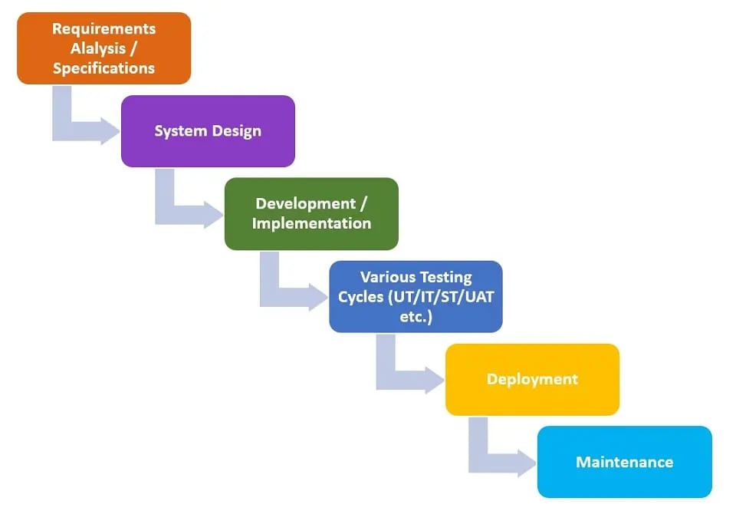

The six stages above are as follows:

**I. Requirement Analysis and Definition:**

What- The systems services, constraints and goals are established by consultation with system users. They are then defined in detail and serve as a system specification.

**II. System and Software Design:**

How – The system design process partitions the requirements to either hardware of software systems. It establishes and overall system architecture. Software design involves fundamental system abstractions and their relationships

**III.Implementation and Unit Testing: -**

How – During this stage the software design is realized as a set of programs or program units. Unit testing involves verifying that each unit meets its specifications.

**IV. Integration and system testing:**

The individual program unit or programs are integrated and tested as a complete system to ensure that the software requirements have been met. After testing, the software system is delivered to the customer.

**V.Deployment:-**

In the Deployment phase, the focus is on ensuring a smooth transition of the software from development to production, and making it available to end-users. This phase involves final testing, packaging, distribution, installation, configuration, user training, and documentation. Once the software is successfully deployed, it is handed over to the maintenance team for ongoing support and maintenance.

**VI. Operation and Maintenance:**

Normally this is the longest phase of the software life cycle. The system is installed and put into practical use. Maintenance involves correcting errors which were not discovered in earlier stages of the life-cycle, improving the implementation of system units and enhancing the system’s services as new requirements are discovered

**2.Spiral Modal:**

The Spiral Model is a [**Software Development Life Cycle (SDLC)**](https://www.geeksforgeeks.org/software-development-life-cycle-sdlc/) model that provides a systematic and iterative approach to software development. In its diagrammatic representation, looks like a spiral with many loops. The exact number of loops of the spiral is unknown and can vary from project to project. Each loop of the spiral is called a **Phase of the**software development.

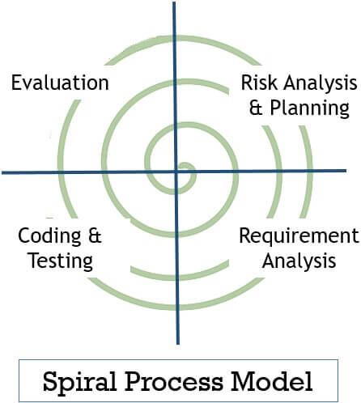

**I. Objectives determination and identify alternative solutions:**

In this first quadrant, the main goal is to gather as much information as possible from the customers. This includes understanding their needs, expectations, and any constraints they may have. Once the objectives are clearly defined, the team starts brainstorming different solutions that could meet these objectives. These solutions are then evaluated based on their feasibility, cost, time, and alignment with the customer’s requirements. The best solutions are shortlisted for further analysis in the next quadrant.

**II. Identify and resolve Risks:**

The second quadrant is all about risk management. The team evaluates the shortlisted solutions from the first quadrant and identifies potential risks associated with each one. These risks could be technical, financial, operational, or even related to the market or customer preferences. Once the risks are identified, the team develops strategies to mitigate them. This could involve modifying the solution, developing contingency plans, or even discarding the solution if the risks are too high. The end result of this quadrant is a prototype of the chosen solution, which is then tested and refined in the next quadrant.

Develop the next version of the Product:

**III. The third quadrant is where the actual development happens.**

Based on the prototype from the second quadrant, the team starts building the features of the product. This involves coding, testing, and debugging. The team also verifies that the product meets the objectives defined in the first quadrant and that the risks identified in the second quadrant have been effectively mitigated. By the end of this quadrant, a new version of the product is ready for review.

**IV. Review and plan for the next Phase:**

The fourth and final quadrant involves reviewing the product with the customers. They evaluate the product to ensure it meets their needs and provides value. The team collects feedback and uses it to improve the product in the next phase. This quadrant also involves planning for the next phase of the Spiral Model, which could involve scaling the product, adding new features, or even starting a new project.

**Choosen Methodology:-**

I will choose vu process Model for my project which is the combination of waterfall and spiral model.

**3.VU Process Model:**

A structured methodology for process management and improvement, comprising four sequential stages.

**I. Vision (Definition and Goal-Setting)**

Define the desired future state of the process (Vision Statement)

Establish clear goals and objectives (SMART criteria)

Identify key performance indicators (KPIs) to measure success

Define the scope and boundaries of the process

Identify stakeholders and their requirements

**II. Understanding (Current State Assessment)**

Analyze the current state of the process (As-Is process mapping)

Identify strengths, weaknesses, opportunities, and threats (SWOT analysis)

Gather data and feedback from stakeholders (surveys, interviews, etc.)

Identify pain points and areas for improvement

Document the current process (process mapping, procedures, etc.)

**III. Upgrading (Process Improvement and Implementation)**

Design and implement process improvements (To-Be process mapping)

Develop new procedures and standards

Train and support stakeholders

Develop a change management plan

Implement the new process (transition from As-Is to To-Be)

**IV. Validation (Monitoring and Evaluation)**

Monitor and evaluate the improved process

Measure KPIs and adjust as needed

Continuously review and refine the process to ensure sustainability

Celebrate successes and recognize improvements

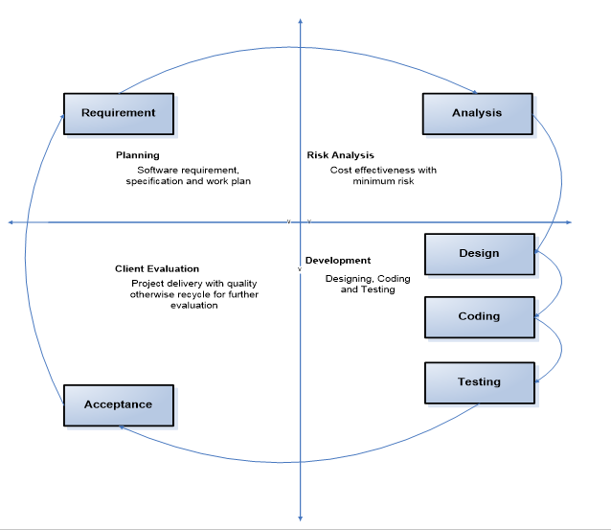

Reasons For Choosing:-

**I.Structured Approach:**

The VU Process Model emphasizes a structured approach to software development. It ensures that you follow a systematic sequence of steps, from requirements gathering to testing and deployment.

**II. Early Specifications and Design:**

Before writing a single line of code, the VU Process Model focuses on creating detailed specifications and design documentation. This minimizes wastage of effort and time and reduces the risk of schedule slippage or unmet customer expectations1.

**III. Risk Management:**

Like the Spiral Model, the VU Process Model incorporates risk management. It allows you to identify and address potential risks early in the project. By iteratively assessing risks, you can make informed decisions and adjust your approach as needed.

**IV. Adaptability:**

The VU Process Model allows for flexibility. You can adapt it to suit your project’s specific needs. For instance, if certain requirements change during development, you can adjust the design and specifications accordingly.

**V. Clear Documentation:**

The model encourages comprehensive documentation at each stage. This documentation serves as a valuable reference for team members, stakeholders, and future maintenance.

**VI. Gantt Chart Planning:**

The VU Process Model recommends creating a Gantt chart to visualize project activities and milestones. This helps manage project timelines effectively

# *WorkPlan:-*

